Tech Tonic: Towards a New Literacy of Technology

http://www.allianceforchildhood.org/sites/allianceforchildhood.org/files/file/pdf/projects/computers/pdf_files/tech_tonic.pdf

- “There is no magic “right” age at which children “should” be using computers. We urge caution, however. Computers involve advanced technologies designed for adults with complex needs for managing information—not for children, whose needs for whole-body, hands-on, and face-to-face learning experiences are just the opposite of what computers offer.”
- “The speed, stimulation and convenience of new technologies draw adults and children to spend more time at work and play with an electronic device placed between them and the rest of the world.”
- “Children invariably love to imitate adults, and may well show an early interest in “playing computer.” But we would not mistake a preschooler’s fascination with fire trucks as evidence that it’s time to sit her behind the wheel of a real hook and ladder. Curiosity about computers and other powerful technologies is not a sign that a child is developmentally ready to operate the real thing.”
- “The most powerful lesson technology may actually teach, over time, is that machines are more compelling than anything that happens in real human interactions.”

- “We call for education that prepares children to participate in discussions and decisions about how technologies can serve democracy, a fair and equitable social order, and ecological sustainability. This is what the Alliance for Childhood has called Technology literacy.”
- “The first priority in technology education-as in all education- is to nurture children’s relationships with other human beings and with the rest of the living world.”
- “To recognize that, in general, there should be a close match between the complexity of the tools children use and their capacity to understand how these tools work.”
- “We cannot expect children to exercise wisdom in the use of technology. They count on us for that wisdom.”
- “Technology is not destiny. IT IS possible for us to reconsider and redirect the impact of technology on childhood.”
- “Preparing students to make conscious choices about technology includes considering how and when to say “no” or “enough”.”
- “A clear goal of instructional technology education for teachers must be to prepare them to make the best choices for the learner in the intended environment.”
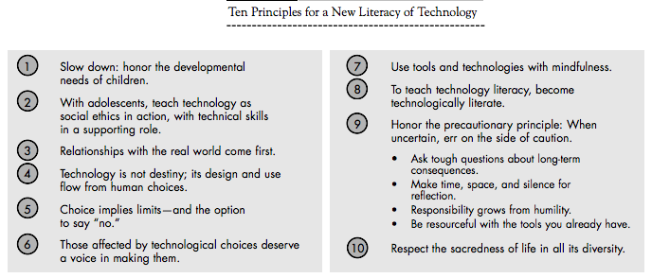

Notes:

